Awesome Python| Frameworks, Libraries, software and resources

Awesome Python
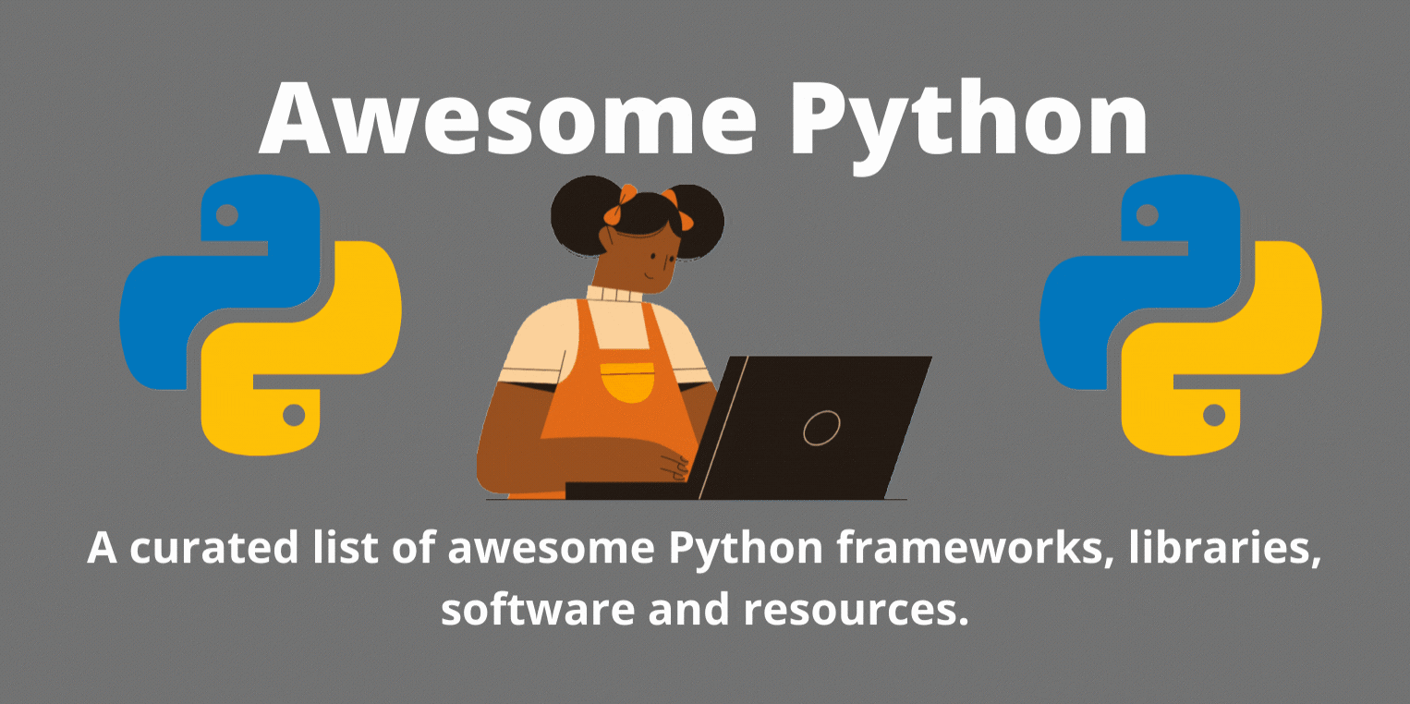
- Table Of contents
  - [Admin Panels]
  - [Algorithms and Design Patterns]
  - [ASGI Servers]
  - [Asynchronous Programming]
  - [Audio]
  - [Authentication]
  - [Build Tools]
  - [Built-in Classes Enhancement]
  - [Caching]
  - [ChatOps Tools]
  - [CMS]
  - [Code Analysis]
  - [Command-line Interface Development]
  - [Command-line Tools]
  - [Compatibility]
  - [Computer Vision]
  - [Concurrency and Parallelism]
  - [Configuration]
  - [Cryptography]
  - [Data Analysis]
  - [Data Validation]
  - [Data Visualization]
  - [Database Drivers]
  - [Database]
  - [Date and Time]
  - [Debugging Tools]
  - [Deep Learning]
  - [DevOps Tools]
  - [Distributed Computing]
  - [Distribution]
  - [Documentation]
  - [Downloader]
  - [E-commerce]
  - [Editor Plugins and IDEs]
  - [Email]
  - [Enterprise Application Integrations]
  - [Environment Management]
  - [Files]
  - [Foreign Function Interface]
  - [Forms]
  - [Functional Programming]
  - [Game Development]
  - [Geolocation]
  - [GUI Development]
  - [Hardware]
  - [HTML Manipulation]
  - [HTTP Clients]
  - [Image Processing]
  - [Implementations]
  - [Interactive Interpreter]
  - [Internationalization]
  - [Job Scheduler]
  - [Logging]
  - [Machine Learning]
  - [Miscellaneous]
  - [Natural Language Processing]
  - [Network Virtualization]
  - [News Feed]
  - [ORM]
  - [Package Management]
  - [Package Repositories]
  - [Penetration testing]
  - [Permissions]
  - [Processes]
  - [Recommender Systems]
  - [Refactoring]
  - [RESTful API]
  - [Robotics]
  - [RPC Servers]
  - [Science]
  - [Search]
  - [Serialization]
  - [Serverless Frameworks]
  - [Shell]
  - [Specific Formats Processing]
  - [Static Site Generator]
  - [Tagging]
  - [Task Queues]
  - [Template Engine]
  - [Testing]
  - [Text Processing]
  - [Third-party APIs]
  - [URL Manipulation]
  - [Video]
  - [Web Asset Management]
  - [Web Content Extracting]
  - [Web Crawling]
  - [Web Frameworks]
  - [WebSocket]
  - [WSGI Servers]
- [Resources]
  - [Books]
  - [Newsletters]
  - [Podcasts]
  - [Websites]

Admin Panels
Libraries for administrative interfaces.
- ajenti - The admin panel your servers deserve.
- django-grappelli - A jazzy skin for the Django Admin-Interface.
- django-jet - Modern responsive template for the Django admin interface with improved functionality.
- django-suit - Alternative Django Admin-Interface (free only for Non-commercial use).
- django-xadmin - Drop-in replacement of Django admin comes with lots of goodies.
- flask-admin - Simple and extensible administrative interface framework for Flask.
- flower - Real-time monitor and web admin for Celery.
- jet-bridge - Admin panel framework for any application with nice UI (ex Jet Django)
- wooey - A Django app which creates automatic web UIs for Python scripts.

Algorithms and Design Patterns
Python implementation of data structures, algorithms and design patterns. Also see awesome-algorithms.
- Algorithms
  - algorithms - Minimal examples of data structures and algorithms.
  - python-ds - A collection of data structure and algorithms for coding interviews.
  - sortedcontainers - Fast and pure-Python implementation of sorted collections.
  - TheAlgorithms - All Algorithms implemented in Python.
- Design Patterns
  - PyPattyrn - A simple yet effective library for implementing common design patterns.
  - python-patterns - A collection of design patterns in Python.
  - transitions - A lightweight, object-oriented finite state machine implementation.

ASGI Servers
ASGI-compatible web servers.
- daphne - A HTTP, HTTP2 and WebSocket protocol server for ASGI and ASGI-HTTP.
- uvicorn - A lightning-fast ASGI server implementation, using uvloop and httptools.

Asynchronous Programming
- asyncio - (Python standard library) Asynchronous I/O, event loop, coroutines and tasks.
  - awesome-asyncio
- trio - A friendly library for async concurrency and I/O.
- Twisted - An event-driven networking engine.
- uvloop - Ultra fast asyncio event loop.

Audio
Libraries for manipulating audio and its metadata.
- Audio
  - audioread - Cross-library (GStreamer + Core Audio + MAD + FFmpeg) audio decoding.
  - dejavu - Audio fingerprinting and recognition.
  - kapre - Keras Audio Preprocessors
  - librosa - Python library for audio and music analysis
  - matchering - A library for automated reference audio mastering.
  - mingus - An advanced music theory and notation package with MIDI file and playback support.
  - pyAudioAnalysis - Audio feature extraction, classification, segmentation and applications.
  - pydub - Manipulate audio with a simple and easy high level interface.
  - TimeSide - Open web audio processing framework.
- Metadata
  - beets - A music library manager and MusicBrainz tagger.
  - eyeD3 - A tool for working with audio files, specifically MP3 files containing ID3 metadata.
  - mutagen - A Python module to handle audio metadata.
  - tinytag - A library for reading music meta data of MP3, OGG, FLAC and Wave files.

Authentication
Libraries for implementing authentications schemes.
- OAuth
  - authlib - JavaScript Object Signing and Encryption draft implementation.
  - django-allauth - Authentication app for Django that “just works.”
  - django-oauth-toolkit - OAuth 2 goodies for Django.
  - oauthlib - A generic and thorough implementation of the OAuth request-signing logic.
  - python-oauth2 - A fully tested, abstract interface to creating OAuth clients and servers.
  - python-social-auth - An easy-to-setup social authentication mechanism.
- JWT
  - pyjwt - JSON Web Token implementation in Python.
  - python-jose - A JOSE implementation in Python.
  - python-jwt - A module for generating and verifying JSON Web Tokens.

Build Tools
Compile software from source code.
- BitBake - A make-like build tool for embedded Linux.
- buildout - A build system for creating, assembling and deploying applications from multiple parts.
- PlatformIO - A console tool to build code with different development platforms.
- pybuilder - A continuous build tool written in pure Python.
- SCons - A software construction tool.

Built-in Classes Enhancement
Libraries for enhancing Python built-in classes.
- attrs - Replacement for __init__ , __eq__ , __repr__ , etc. boilerplate in class definitions.
- bidict - Efficient, Pythonic bidirectional map data structures and related functionality…
- Box - Python dictionaries with advanced dot notation access.
- dataclasses - (Python standard library) Data classes.
- DottedDict - A library that provides a method of accessing lists and dicts with a dotted path notation.

CMS
Content Management Systems.
- django-cms - An Open source enterprise CMS based on the Django.
- feincms - One of the most advanced Content Management Systems built on Django.
- indico - A feature-rich event management system, made @ CERN.
- Kotti - A high-level, Pythonic web application framework built on Pyramid.
- mezzanine - A powerful, consistent, and flexible content management platform.
- plone - A CMS built on top of the open source application server Zope.
- quokka - Flexible, extensible, small CMS powered by Flask and MongoDB.
- wagtail - A Django content management system.

Caching
Libraries for caching data.
- beaker - A WSGI middleware for sessions and caching.
- django-cache-machine - Automatic caching and invalidation for Django models.
- django-cacheops - A slick ORM cache with automatic granular event-driven invalidation.
- dogpile.cache - dogpile.cache is next generation replacement for Beaker made by same authors.
- HermesCache - Python caching library with tag-based invalidation and dogpile effect prevention.
- pylibmc - A Python wrapper around the libmemcached interface.
- python-diskcache - SQLite and file backed cache backend with faster lookups than memcached and redis.

ChatOps Tools
Libraries for chatbot development.
- errbot - The easiest and most popular chatbot to implement ChatOps.

Code Analysis
Tools of static analysis, linters and code quality checkers. Also see awesome-static-analysis.
- Code Analysis
  - coala - Language independent and easily extendable code analysis application.
  - code2flow - Turn your Python and JavaScript code into DOT flowcharts.
  - prospector - A tool to analyse Python code.
  - pycallgraph - A library that visualises the flow (call graph) of your Python application.
  - vulture - A tool for finding and analysing dead Python code.
- Code Linters
  - flake8 - A wrapper around pycodestyle , pyflakes and McCabe.
    - awesome-flake8-extensions
  - pylama - A code audit tool for Python and JavaScript.
  - pylint - A fully customizable source code analyzer.
  - wemake-python-styleguide - The strictest and most opinionated python linter ever.
- Code Formatters
  - black - The uncompromising Python code formatter.
  - isort - A Python utility / library to sort imports.
  - yapf - Yet another Python code formatter from Google.
- Static Type Checkers, also see awesome-python-typing
  - mypy - Check variable types during compile time.
  - pyre-check - Performant type checking.
  - typeshed - Collection of library stubs for Python, with static types.
- Static Type Annotations Generators
  - MonkeyType - A system for Python that generates static type annotations by collecting runtime types.
  - pyannotate - Auto-generate PEP-484 annotations.
  - pytype - Pytype checks and infers types for Python code - without requiring type annotations.

Command-line Interface Development
Libraries for building command-line applications.
- Command-line Application Development
  - cement - CLI Application Framework for Python.
  - click - A package for creating beautiful command line interfaces in a composable way.
  - cliff - A framework for creating command-line programs with multi-level commands.
  - docopt - Pythonic command line arguments parser.
  - python-fire - A library for creating command line interfaces from absolutely any Python object.
  - python-prompt-toolkit - A library for building powerful interactive command lines.
- Terminal Rendering
  - alive-progress - A new kind of Progress Bar, with real-time throughput, eta and very cool animations.
  - asciimatics - A package to create full-screen text UIs (from interactive forms to ASCII animations).
  - bashplotlib - Making basic plots in the terminal.
  - colorama - Cross-platform colored terminal text.
  - rich - Python library for rich text and beautiful formatting in the terminal. Also provides a great RichHandler log handler.
  - tqdm - Fast, extensible progress bar for loops and CLI.

Command-line Tools
Useful CLI-based tools for productivity.
- Productivity Tools
  - copier - A library and command-line utility for rendering projects templates.
  - cookiecutter - A command-line utility that creates projects from cookiecutters (project templates).
  - doitlive - A tool for live presentations in the terminal.
  - howdoi - Instant coding answers via the command line.
  - Invoke - A tool for managing shell-oriented subprocesses and organizing executable Python code into CLI-invokable tasks.
  - PathPicker - Select files out of bash output.
  - percol - Adds flavor of interactive selection to the traditional pipe concept on UNIX.
  - thefuck - Correcting your previous console command.
  - tmuxp - A tmux session manager.
  - try - A dead simple CLI to try out python packages - it’s never been easier.
- CLI Enhancements
  - httpie - A command line HTTP client, a user-friendly cURL replacement.
  - iredis - Redis CLI with autocompletion and syntax highlighting.
  - kube-shell - An integrated shell for working with the Kubernetes CLI.
  - litecli - SQLite CLI with autocompletion and syntax highlighting.
  - mycli - MySQL CLI with autocompletion and syntax highlighting.
  - pgcli - PostgreSQL CLI with autocompletion and syntax highlighting.
  - saws - A Supercharged aws-cli.

Compatibility
Libraries for migrating from Python 2 to 3.
- python-future - The missing compatibility layer between Python 2 and Python 3.
- modernize - Modernizes Python code for eventual Python 3 migration.
- six - Python 2 and 3 compatibility utilities.

Computer Vision
Libraries for Computer Vision.
- EasyOCR - Ready-to-use OCR with 40+ languages supported.
- Face Recognition - Simple facial recognition library.
- Kornia - Open Source Differentiable Computer Vision Library for PyTorch.
- OpenCV - Open Source Computer Vision Library.
- pytesseract - A wrapper for Google Tesseract OCR.
- SimpleCV - An open source framework for building computer vision applications.
- tesserocr - Another simple, Pillow-friendly, wrapper around the tesseract-ocr API for OCR.

Concurrency and Parallelism
Libraries for concurrent and parallel execution. Also see awesome-asyncio.
- concurrent.futures - (Python standard library) A high-level interface for asynchronously executing callables.
- eventlet - Asynchronous framework with WSGI support.
- gevent - A coroutine-based Python networking library that uses greenlet.
- multiprocessing - (Python standard library) Process-based parallelism.
- scoop - Scalable Concurrent Operations in Python.
- uvloop - Ultra fast implementation of asyncio event loop on top of libuv .

Configuration
Libraries for storing and parsing configuration options.
- configobj - INI file parser with validation.
- configparser - (Python standard library) INI file parser.
- hydra - Hydra is a framework for elegantly configuring complex applications.
- profig - Config from multiple formats with value conversion.
- python-decouple - Strict separation of settings from code.

Cryptography
- cryptography - A package designed to expose cryptographic primitives and recipes to Python developers.
- paramiko - The leading native Python SSHv2 protocol library.
- passlib - Secure password storage/hashing library, very high level.
- pynacl - Python binding to the Networking and Cryptography (NaCl) library.

Data Analysis
Libraries for data analyzing.
- AWS Data Wrangler - Pandas on AWS.
- Blaze - NumPy and Pandas interface to Big Data.
- Open Mining - Business Intelligence (BI) in Pandas interface.
- Optimus - Agile Data Science Workflows made easy with PySpark.
- Orange - Data mining, data visualization, analysis and machine learning through visual programming or scripts.
- Pandas - A library providing high-performance, easy-to-use data structures and data analysis tools.

Data Validation
Libraries for validating data. Used for forms in many cases.
- Cerberus - A lightweight and extensible data validation library.
- colander - Validating and deserializing data obtained via XML, JSON, an HTML form post.
- jsonschema - An implementation of JSON Schema for Python.
- schema - A library for validating Python data structures.
- Schematics - Data Structure Validation.
- valideer - Lightweight extensible data validation and adaptation library.
- voluptuous - A Python data validation library.

Data Visualization
Libraries for visualizing data. Also see awesome-javascript.
- Altair - Declarative statistical visualization library for Python.
- Bokeh - Interactive Web Plotting for Python.
- bqplot - Interactive Plotting Library for the Jupyter Notebook
- Cartopy - A cartographic python library with matplotlib support
- Dash - Built on top of Flask, React and Plotly aimed at analytical web applications.
  - awesome-dash
- diagrams - Diagram as Code.
- Matplotlib - A Python 2D plotting library.
- plotnine - A grammar of graphics for Python based on ggplot2.
- Pygal - A Python SVG Charts Creator.
- PyGraphviz - Python interface to Graphviz.
- PyQtGraph - Interactive and realtime 2D/3D/Image plotting and science/engineering widgets.
- Seaborn - Statistical data visualization using Matplotlib.
- VisPy - High-performance scientific visualization based on OpenGL.

Database
Databases implemented in Python.
- pickleDB - A simple and lightweight key-value store for Python.
- tinydb - A tiny, document-oriented database.
- ZODB - A native object database for Python. A key-value and object graph database.

Database Drivers
Libraries for connecting and operating databases.
- MySQL - awesome-mysql
  - mysqlclient - MySQL connector with Python 3 support (mysql-python fork).
  - PyMySQL - A pure Python MySQL driver compatible to mysql-python.
- PostgreSQL - awesome-postgres
  - psycopg2 - The most popular PostgreSQL adapter for Python.
  - queries - A wrapper of the psycopg2 library for interacting with PostgreSQL.
- SQlite - awesome-sqlite
  - sqlite3 - (Python standard library) SQlite interface compliant with DB-API 2.0
  - SuperSQLite - A supercharged SQLite library built on top of apsw.
- Other Relational Databases
  - pymssql - A simple database interface to Microsoft SQL Server.
  - clickhouse-driver - Python driver with native interface for ClickHouse.
- NoSQL Databases
  - cassandra-driver - The Python Driver for Apache Cassandra.
  - happybase - A developer-friendly library for Apache HBase.
  - kafka-python - The Python client for Apache Kafka.
  - py2neo - A client library and toolkit for working with Neo4j.
  - pymongo - The official Python client for MongoDB.
  - redis-py - The Python client for Redis.
- Asynchronous Clients
  - motor - The async Python driver for MongoDB.

Date and Time
Libraries for working with dates and times.
- Arrow - A Python library that offers a sensible and human-friendly approach to creating, manipulating, formatting and converting dates, times and timestamps.
- Chronyk - A Python 3 library for parsing human-written times and dates.
- dateutil - Extensions to the standard Python datetime module.
- delorean - A library for clearing up the inconvenient truths that arise dealing with datetimes.
- maya - Datetimes for Humans.
- moment - A Python library for dealing with dates/times. Inspired by Moment.js.
- Pendulum - Python datetimes made easy.
- PyTime - An easy-to-use Python module which aims to operate date/time/datetime by string.
- pytz - World timezone definitions, modern and historical. Brings the tz database into Python.
- when.py - Providing user-friendly functions to help perform common date and time actions.

Debugging Tools
Libraries for debugging code.
- pdb-like Debugger
  - ipdb - IPython-enabled pdb.
  - pdb++ - Another drop-in replacement for pdb.
  - pudb - A full-screen, console-based Python debugger.
  - wdb - An improbable web debugger through WebSockets.
- Tracing
  - lptrace - strace for Python programs.
  - manhole - Debugging UNIX socket connections and present the stacktraces for all threads and an interactive prompt.
  - pyringe - Debugger capable of attaching to and injecting code into Python processes.
  - python-hunter - A flexible code tracing toolkit.
- Profiler
  - line_profiler - Line-by-line profiling.
  - memory_profiler - Monitor Memory usage of Python code.
  - py-spy - A sampling profiler for Python programs. Written in Rust.
  - pyflame - A ptracing profiler For Python.
  - vprof - Visual Python profiler.
- Others
  - django-debug-toolbar - Display various debug information for Django.
  - django-devserver - A drop-in replacement for Django’s runserver.
  - flask-debugtoolbar - A port of the django-debug-toolbar to flask.
  - icecream - Inspect variables, expressions, and program execution with a single, simple function call.
  - pyelftools - Parsing and analyzing ELF files and DWARF debugging information.

Deep Learning
Frameworks for Neural Networks and Deep Learning. Also see awesome-deep-learning.
- caffe - A fast open framework for deep learning…
- keras - A high-level neural networks library and capable of running on top of either TensorFlow or Theano.
- mxnet - A deep learning framework designed for both efficiency and flexibility.
- pytorch - Tensors and Dynamic neural networks in Python with strong GPU acceleration.
- SerpentAI - Game agent framework. Use any video game as a deep learning sandbox.
- tensorflow - The most popular Deep Learning framework created by Google.
- Theano - A library for fast numerical computation.

DevOps Tools
Software and libraries for DevOps.
- Configuration Management
  - ansible - A radically simple IT automation platform.
  - cloudinit - A multi-distribution package that handles early initialization of a cloud instance.
  - OpenStack - Open source software for building private and public clouds.
  - pyinfra - A versatile CLI tools and python libraries to automate infrastructure.
  - saltstack - Infrastructure automation and management system.
- SSH-style Deployment
  - cuisine - Chef-like functionality for Fabric.
  - fabric - A simple, Pythonic tool for remote execution and deployment.
  - fabtools - Tools for writing awesome Fabric files.
- Process Management
  - honcho - A Python clone of Foreman, for managing Procfile-based applications.
  - supervisor - Supervisor process control system for UNIX.
- Monitoring
  - psutil - A cross-platform process and system utilities module.
- Backup
  - BorgBackup - A deduplicating archiver with compression and encryption.
- Others
  - docker-compose - Fast, isolated development environments using Docker.

Distributed Computing
Frameworks and libraries for Distributed Computing.
- Batch Processing
  - dask - A flexible parallel computing library for analytic computing.
  - luigi - A module that helps you build complex pipelines of batch jobs.
  - mrjob - Run MapReduce jobs on Hadoop or Amazon Web Services.
  - PySpark - Apache Spark Python API.
  - Ray - A system for parallel and distributed Python that unifies the machine learning ecosystem.
- Stream Processing
  - faust - A stream processing library, porting the ideas from Kafka Streams to Python.
  - streamparse - Run Python code against real-time streams of data via Apache Storm.

Distribution
Libraries to create packaged executables for release distribution.
- dh-virtualenv - Build and distribute a virtualenv as a Debian package.
- Nuitka - Compile scripts, modules, packages to an executable or extension module.
- py2app - Freezes Python scripts (Mac OS X).
- py2exe - Freezes Python scripts (Windows).
- pyarmor - A tool used to obfuscate python scripts, bind obfuscated scripts to fixed machine or expire obfuscated scripts.
- PyInstaller - Converts Python programs into stand-alone executables (cross-platform).
- pynsist - A tool to build Windows installers, installers bundle Python itself.
- shiv - A command line utility for building fully self-contained zipapps (PEP 441), but with all their dependencies included.

Documentation
Libraries for generating project documentation.
- sphinx - Python Documentation generator.
  - awesome-sphinxdoc
- pdoc - Epydoc replacement to auto generate API documentation for Python libraries.
- pycco - The literate-programming-style documentation generator.

Downloader
Libraries for downloading.
- akshare - A financial data interface library, built for human beings!
- s3cmd - A command line tool for managing Amazon S3 and CloudFront.
- s4cmd - Super S3 command line tool, good for higher performance.
- you-get - A YouTube/Youku/Niconico video downloader written in Python 3.
- youtube-dl - A small command-line program to download videos from YouTube.

E-commerce
Frameworks and libraries for e-commerce and payments.
- alipay - Unofficial Alipay API for Python.
- Cartridge - A shopping cart app built using the Mezzanine.
- django-oscar - An open-source e-commerce framework for Django.
- django-shop - A Django based shop system.
- forex-python - Foreign exchange rates, Bitcoin price index and currency conversion.
- merchant - A Django app to accept payments from various payment processors.
- money - Money class with optional CLDR-backed locale-aware formatting and an extensible currency exchange.
- python-currencies - Display money format and its filthy currencies.
- saleor - An e-commerce storefront for Django.
- shoop - An open source E-Commerce platform based on Django.

Editor Plugins and IDEs
- Emacs
  - elpy - Emacs Python Development Environment.
- Sublime Text
  - anaconda - Anaconda turns your Sublime Text 3 in a full featured Python development IDE.
  - SublimeJEDI - A Sublime Text plugin to the awesome auto-complete library Jedi.
- Vim
  - jedi-vim - Vim bindings for the Jedi auto-completion library for Python.
  - python-mode - An all in one plugin for turning Vim into a Python IDE.
  - YouCompleteMe - Includes Jedi-based completion engine for Python.
- Visual Studio
  - PTVS - Python Tools for Visual Studio.
- Visual Studio Code
  - Python - The official VSCode extension with rich support for Python.
- IDE
  - PyCharm - Commercial Python IDE by JetBrains. Has free community edition available.
  - spyder - Open Source Python IDE.

Email
Libraries for sending and parsing email.
- Mail Servers
  - modoboa - A mail hosting and management platform including a modern Web UI.
  - salmon - A Python Mail Server.
- Clients
  - imbox - Python IMAP for Humans.
  - yagmail - Yet another Gmail/SMTP client.
- Others
  - flanker - An email address and Mime parsing library.
  - mailer - High-performance extensible mail delivery framework.

Enterprise Application Integrations
Platforms and tools for systems integrations in enterprise environments
- Zato - ESB, SOA, REST, APIs and Cloud Integrations in Python.

Environment Management
Libraries for Python version and virtual environment management.
- pyenv - Simple Python version management.
- virtualenv - A tool to create isolated Python environments.

Files
Libraries for file manipulation and MIME type detection.
- mimetypes - (Python standard library) Map filenames to MIME types.
- path.py - A module wrapper for os.path.
- pathlib - (Python standard library) An cross-platform, object-oriented path library.
- PyFilesystem2 - Python’s filesystem abstraction layer.
- python-magic - A Python interface to the libmagic file type identification library.
- Unipath - An object-oriented approach to file/directory operations.
- watchdog - API and shell utilities to monitor file system events.

Foreign Function Interface
Libraries for providing foreign function interface.
- cffi - Foreign Function Interface for Python calling C code.
- ctypes - (Python standard library) Foreign Function Interface for Python calling C code.
- PyCUDA - A Python wrapper for Nvidia’s CUDA API.
- SWIG - Simplified Wrapper and Interface Generator.

Forms
Libraries for working with forms.
- Deform - Python HTML form generation library influenced by the formish form generation library.
- django-bootstrap3 - Bootstrap 3 integration with Django.
- django-bootstrap4 - Bootstrap 4 integration with Django.
- django-crispy-forms - A Django app which lets you create beautiful forms in a very elegant and DRY way.
- django-remote-forms - A platform independent Django form serializer.
- WTForms - A flexible forms validation and rendering library.

Functional Programming
Functional Programming with Python.
- Coconut - A variant of Python built for simple, elegant, Pythonic functional programming.
- CyToolz - Cython implementation of Toolz : High performance functional utilities.
- fn.py - Functional programming in Python: implementation of missing features to enjoy FP.
- funcy - A fancy and practical functional tools.
- more-itertools - More routines for operating on iterables, beyond itertools .
- returns - A set of type-safe monads, transformers, and composition utilities.
- Toolz - A collection of functional utilities for iterators, functions, and dictionaries.

GUI Development
Libraries for working with graphical user interface applications.
- curses - Built-in wrapper for ncurses used to create terminal GUI applications.
- Eel - A library for making simple Electron-like offline HTML/JS GUI apps.
- enaml - Creating beautiful user-interfaces with Declarative Syntax like QML.
- Flexx - Flexx is a pure Python toolkit for creating GUI’s, that uses web technology for its rendering.
- Gooey - Turn command line programs into a full GUI application with one line.
- kivy - A library for creating NUI applications, running on Windows, Linux, Mac OS X, Android and iOS.
- pyglet - A cross-platform windowing and multimedia library for Python.
- PyGObject - Python Bindings for GLib/GObject/GIO/GTK+ (GTK+3).
- PyQt - Python bindings for the Qt cross-platform application and UI framework.
- PySimpleGUI - Wrapper for tkinter, Qt, WxPython and Remi.
- pywebview - A lightweight cross-platform native wrapper around a webview component.
- Tkinter - Tkinter is Python’s de-facto standard GUI package.
- Toga - A Python native, OS native GUI toolkit.
- urwid - A library for creating terminal GUI applications with strong support for widgets, events, rich colors, etc.
- wxPython - A blending of the wxWidgets C++ class library with the Python.
- DearPyGui - A Simple GPU accelerated Python GUI framework

GraphQL
Libraries for working with GraphQL.
- graphene - GraphQL framework for Python.
- tartiflette-aiohttp - An aiohttp -based wrapper for Tartiflette to expose GraphQL APIs over HTTP.
- tartiflette-asgi - ASGI support for the Tartiflette GraphQL engine.
- tartiflette - SDL-first GraphQL engine implementation for Python 3.6+ and asyncio.

Game Development
Awesome game development libraries.
- Arcade - Arcade is a modern Python framework for crafting games with compelling graphics and sound.
- Cocos2d - cocos2d is a framework for building 2D games, demos, and other graphical/interactive applications.
- Harfang3D - Python framework for 3D, VR and game development.
- Panda3D - 3D game engine developed by Disney.
- Pygame - Pygame is a set of Python modules designed for writing games.
- PyOgre - Python bindings for the Ogre 3D render engine, can be used for games, simulations, anything 3D.
- PyOpenGL - Python ctypes bindings for OpenGL and it’s related APIs.
- PySDL2 - A ctypes based wrapper for the SDL2 library.
- RenPy - A Visual Novel engine.

Geolocation
Libraries for geocoding addresses and working with latitudes and longitudes.
- django-countries - A Django app that provides a country field for models and forms.
- GeoDjango - A world-class geographic web framework.
- GeoIP - Python API for MaxMind GeoIP Legacy Database.
- geojson - Python bindings and utilities for GeoJSON.
- geopy - Python Geocoding Toolbox.

HTML Manipulation
Libraries for working with HTML and XML.
- BeautifulSoup - Providing Pythonic idioms for iterating, searching, and modifying HTML or XML.
- bleach - A whitelist-based HTML sanitization and text linkification library.
- cssutils - A CSS library for Python.
- html5lib - A standards-compliant library for parsing and serializing HTML documents and fragments.
- lxml - A very fast, easy-to-use and versatile library for handling HTML and XML.
- MarkupSafe - Implements a XML/HTML/XHTML Markup safe string for Python.
- pyquery - A jQuery-like library for parsing HTML.
- untangle - Converts XML documents to Python objects for easy access.
- WeasyPrint - A visual rendering engine for HTML and CSS that can export to PDF.
- xmldataset - Simple XML Parsing.
- xmltodict - Working with XML feel like you are working with JSON.

HTTP Clients
Libraries for working with HTTP.
- grequests - requests + gevent for asynchronous HTTP requests.
- httplib2 - Comprehensive HTTP client library.
- httpx - A next generation HTTP client for Python.
- requests - HTTP Requests for Humans.
- treq - Python requests like API built on top of Twisted’s HTTP client.
- urllib3 - A HTTP library with thread-safe connection pooling, file post support, sanity friendly.

Hardware
Libraries for programming with hardware.
- ino - Command line toolkit for working with Arduino.
- keyboard - Hook and simulate global keyboard events on Windows and Linux.
- mouse - Hook and simulate global mouse events on Windows and Linux.
- Pingo - Pingo provides a uniform API to program devices like the Raspberry Pi, pcDuino, Intel Galileo, etc.
- PyUserInput - A module for cross-platform control of the mouse and keyboard.
- scapy - A brilliant packet manipulation library.

Image Processing
Libraries for manipulating images.
- hmap - Image histogram remapping.
- imgSeek - A project for searching a collection of images using visual similarity.
- nude.py - Nudity detection.
- pagan - Retro identicon (Avatar) generation based on input string and hash.
- pillow - Pillow is the friendly PIL fork.
- python-barcode - Create barcodes in Python with no extra dependencies.
- pygram - Instagram-like image filters.
- PyMatting - A library for alpha matting.
- python-qrcode - A pure Python QR Code generator.
- pywal - A tool that generates color schemes from images.
- pyvips - A fast image processing library with low memory needs.
- Quads - Computer art based on quadtrees.
- scikit-image - A Python library for (scientific) image processing.
- thumbor - A smart imaging service. It enables on-demand crop, re-sizing and flipping of images.
- wand - Python bindings for MagickWand, C API for ImageMagick.

Implementations
Implementations of Python.
- CLPython - Implementation of the Python programming language written in Common Lisp.
- CPython - Default, most widely used implementation of the Python programming language written in C.
- Cython - Optimizing Static Compiler for Python.
- Grumpy - More compiler than interpreter as more powerful CPython2.7 replacement (alpha).
- IronPython - Implementation of the Python programming language written in C#.
- Jython - Implementation of Python programming language written in Java for the JVM.
- MicroPython - A lean and efficient Python programming language implementation.
- Numba - Python JIT compiler to LLVM aimed at scientific Python.
- PeachPy - x86-64 assembler embedded in Python.
- Pyjion - A JIT for Python based upon CoreCLR.
- PyPy - A very fast and compliant implementation of the Python language.
- Pyston - A Python implementation using JIT techniques.
- Stackless Python - An enhanced version of the Python programming language.

Interactive Interpreter
Interactive Python interpreters (REPL).
- bpython - A fancy interface to the Python interpreter.
- Jupyter Notebook (IPython) - A rich toolkit to help you make the most out of using Python interactively.
  - awesome-jupyter
- ptpython - Advanced Python REPL built on top of the python-prompt-toolkit.

Internationalization
Libraries for working with i18n.
- Babel - An internationalization library for Python.
- PyICU - A wrapper of International Components for Unicode C++ library (ICU).

Job Scheduler
Libraries for scheduling jobs.
- Airflow - Airflow is a platform to programmatically author, schedule and monitor workflows.
- APScheduler - A light but powerful in-process task scheduler that lets you schedule functions.
- django-schedule - A calendaring app for Django.
- doit - A task runner and build tool.
- gunnery - Multipurpose task execution tool for distributed systems with web-based interface.
- Joblib - A set of tools to provide lightweight pipelining in Python.
- Plan - Writing crontab file in Python like a charm.
- Prefect - A modern workflow orchestration framework that makes it easy to build, schedule and monitor robust data pipelines.
- schedule - Python job scheduling for humans.
- Spiff - A powerful workflow engine implemented in pure Python.
- TaskFlow - A Python library that helps to make task execution easy, consistent and reliable.

Logging
Libraries for generating and working with logs.
- logbook - Logging replacement for Python.
- logging - (Python standard library) Logging facility for Python.
- loguru - Library which aims to bring enjoyable logging in Python.
- sentry-python - Sentry SDK for Python.
- structlog - Structured logging made easy.

Machine Learning
Libraries for Machine Learning. Also see awesome-machine-learning.
- gym - A toolkit for developing and comparing reinforcement learning algorithms.
- H2O - Open Source Fast Scalable Machine Learning Platform.
- Metrics - Machine learning evaluation metrics.
- NuPIC - Numenta Platform for Intelligent Computing.
- scikit-learn - The most popular Python library for Machine Learning.
- Spark ML - Apache Spark’s scalable Machine Learning library.
- vowpal_porpoise - A lightweight Python wrapper for Vowpal Wabbit.
- xgboost - A scalable, portable, and distributed gradient boosting library.
- MindsDB - MindsDB is an open source AI layer for existing databases that allows you to effortlessly develop, train and deploy state-of-the-art machine learning models using standard queries.

Microsoft Windows
Python programming on Microsoft Windows.
- Python(x,y) - Scientific-applications-oriented Python Distribution based on Qt and Spyder.
- pythonlibs - Unofficial Windows binaries for Python extension packages.
- PythonNet - Python Integration with the .NET Common Language Runtime (CLR).
- PyWin32 - Python Extensions for Windows.
- WinPython - Portable development environment for Windows 7/8.

Miscellaneous
Useful libraries or tools that don’t fit in the categories above.
- blinker - A fast Python in-process signal/event dispatching system.
- boltons - A set of pure-Python utilities.
- itsdangerous - Various helpers to pass trusted data to untrusted environments.
- magenta - A tool to generate music and art using artificial intelligence.
- pluginbase - A simple but flexible plugin system for Python.
- tryton - A general purpose business framework.

Natural Language Processing
Libraries for working with human languages.
- General
  - gensim - Topic Modeling for Humans.
  - langid.py - Stand-alone language identification system.
  - nltk - A leading platform for building Python programs to work with human language data.
  - pattern - A web mining module.
  - polyglot - Natural language pipeline supporting hundreds of languages.
  - pytext - A natural language modeling framework based on PyTorch.
  - PyTorch-NLP - A toolkit enabling rapid deep learning NLP prototyping for research.
  - spacy - A library for industrial-strength natural language processing in Python and Cython.
  - Stanza - The Stanford NLP Group’s official Python library, supporting 60+ languages.
- Chinese
  - funNLP - A collection of tools and datasets for Chinese NLP.
  - jieba - The most popular Chinese text segmentation library.
  - pkuseg-python - A toolkit for Chinese word segmentation in various domains.
  - snownlp - A library for processing Chinese text.

Network Virtualization
Tools and libraries for Virtual Networking and SDN (Software Defined Networking).
- mininet - A popular network emulator and API written in Python.
- napalm - Cross-vendor API to manipulate network devices.
- pox - A Python-based SDN control applications, such as OpenFlow SDN controllers.

News Feed
Libraries for building user’s activities.
- django-activity-stream - Generating generic activity streams from the actions on your site.
- Stream Framework - Building news feed and notification systems using Cassandra and Redis.

ORM
Libraries that implement Object-Relational Mapping or data mapping techniques.
- Relational Databases
  - Django Models - The Django ORM.
  - SQLAlchemy - The Python SQL Toolkit and Object Relational Mapper.
    - awesome-sqlalchemy
  - dataset - Store Python dicts in a database - works with SQLite, MySQL, and PostgreSQL.
  - orator - The Orator ORM provides a simple yet beautiful ActiveRecord implementation.
  - orm - An async ORM.
  - peewee - A small, expressive ORM.
  - pony - ORM that provides a generator-oriented interface to SQL.
  - pydal - A pure Python Database Abstraction Layer.
- NoSQL Databases
  - hot-redis - Rich Python data types for Redis.
  - mongoengine - A Python Object-Document-Mapper for working with MongoDB.
  - PynamoDB - A Pythonic interface for Amazon DynamoDB.
  - redisco - A Python Library for Simple Models and Containers Persisted in Redis.

Package Management
Libraries for package and dependency management.
- pip - The package installer for Python.
  - pip-tools - A set of tools to keep your pinned Python dependencies fresh.
  - PyPI
- conda - Cross-platform, Python-agnostic binary package manager.
- poetry - Python dependency management and packaging made easy.

Package Repositories
Local PyPI repository server and proxies.
- bandersnatch - PyPI mirroring tool provided by Python Packaging Authority (PyPA).
- devpi - PyPI server and packaging/testing/release tool.
- localshop - Local PyPI server (custom packages and auto-mirroring of pypi).
- warehouse - Next generation Python Package Repository (PyPI).

Penetration Testing
Frameworks and tools for penetration testing.
- fsociety - A Penetration testing framework.
- setoolkit - A toolkit for social engineering.
- sqlmap - Automatic SQL injection and database takeover tool.

Permissions
Libraries that allow or deny users access to data or functionality.
- django-guardian - Implementation of per object permissions for Django 1.2+
- django-rules - A tiny but powerful app providing object-level permissions to Django, without requiring a database.

Processes
Libraries for starting and communicating with OS processes.
- delegator.py - Subprocesses for Humans 2.0.
- sarge - Yet another wrapper for subprocess.
- sh - A full-fledged subprocess replacement for Python.

Recommender Systems
Libraries for building recommender systems.
- annoy - Approximate Nearest Neighbors in C++/Python optimized for memory usage.
- fastFM - A library for Factorization Machines.
- implicit - A fast Python implementation of collaborative filtering for implicit datasets.
- libffm - A library for Field-aware Factorization Machine (FFM).
- lightfm - A Python implementation of a number of popular recommendation algorithms.
- spotlight - Deep recommender models using PyTorch.
- Surprise - A scikit for building and analyzing recommender systems.
- tensorrec - A Recommendation Engine Framework in TensorFlow.

Refactoring
Refactoring tools and libraries for Python
- Bicycle Repair Man - Bicycle Repair Man, a refactoring tool for Python.
- Bowler - Safe code refactoring for modern Python.
- Rope - Rope is a python refactoring library.

RESTful API
Libraries for building RESTful APIs.
- Django
  - django-rest-framework - A powerful and flexible toolkit to build web APIs.
  - django-tastypie - Creating delicious APIs for Django apps.
- Flask
  - eve - REST API framework powered by Flask, MongoDB and good intentions.
  - flask-api - Browsable Web APIs for Flask.
  - flask-restful - Quickly building REST APIs for Flask.
- Pyramid
  - cornice - A RESTful framework for Pyramid.
- Framework agnostic
  - apistar - A smart Web API framework, designed for Python 3.
  - falcon - A high-performance framework for building cloud APIs and web app backends.
  - fastapi - A modern, fast, web framework for building APIs with Python 3.6+ based on standard Python type hints.
  - hug - A Python 3 framework for cleanly exposing APIs.
  - sandman2 - Automated REST APIs for existing database-driven systems.
  - sanic - A Python 3.6+ web server and web framework that’s written to go fast.
  - vibora - Fast, efficient and asynchronous Web framework inspired by Flask.

Robotics
Libraries for robotics.
- PythonRobotics - This is a compilation of various robotics algorithms with visualizations.
- rospy - This is a library for ROS (Robot Operating System).

RPC Servers
RPC-compatible servers.
- RPyC (Remote Python Call) - A transparent and symmetric RPC library for Python
- zeroRPC - zerorpc is a flexible RPC implementation based on ZeroMQ and MessagePack.

Science
Libraries for scientific computing. Also see Python-for-Scientists.
- astropy - A community Python library for Astronomy.
- bcbio-nextgen - Providing best-practice pipelines for fully automated high throughput sequencing analysis.
- bccb - Collection of useful code related to biological analysis.
- Biopython - Biopython is a set of freely available tools for biological computation.
- cclib - A library for parsing and interpreting the results of computational chemistry packages.
- Colour - Implementing a comprehensive number of colour theory transformations and algorithms.
- Karate Club - Unsupervised machine learning toolbox for graph structured data.
- NetworkX - A high-productivity software for complex networks.
- NIPY - A collection of neuroimaging toolkits.
- NumPy - A fundamental package for scientific computing with Python.
- ObsPy - A Python toolbox for seismology.
- Open Babel - A chemical toolbox designed to speak the many languages of chemical data.
- PyDy - Short for Python Dynamics, used to assist with workflow in the modeling of dynamic motion.
- PyMC - Markov Chain Monte Carlo sampling toolkit.
- QuTiP - Quantum Toolbox in Python.
- RDKit - Cheminformatics and Machine Learning Software.
- SciPy - A Python-based ecosystem of open-source software for mathematics, science, and engineering.
- SimPy - A process-based discrete-event simulation framework.
- statsmodels - Statistical modeling and econometrics in Python.
- SymPy - A Python library for symbolic mathematics.
- Zipline - A Pythonic algorithmic trading library.

Search
Libraries and software for indexing and performing search queries on data.
- django-haystack - Modular search for Django.
- elasticsearch-dsl-py - The official high-level Python client for Elasticsearch.
- elasticsearch-py - The official low-level Python client for Elasticsearch.
- pysolr - A lightweight Python wrapper for Apache Solr.
- whoosh - A fast, pure Python search engine library.

Serialization
Libraries for serializing complex data types
- marshmallow - A lightweight library for converting complex objects to and from simple Python datatypes.
- pysimdjson - A Python bindings for simdjson.
- python-rapidjson - A Python wrapper around RapidJSON.
- ultrajson - A fast JSON decoder and encoder written in C with Python bindings.

Serverless Frameworks
Frameworks for developing serverless Python code.
- python-lambda - A toolkit for developing and deploying Python code in AWS Lambda.
- Zappa - A tool for deploying WSGI applications on AWS Lambda and API Gateway.

Shell
Shells based on Python.
- xonsh - A Python-powered, cross-platform, Unix-gazing shell language and command prompt.

Specific Formats Processing
Libraries for parsing and manipulating specific text formats.
- General
  - tablib - A module for Tabular Datasets in XLS, CSV, JSON, YAML.
- Office
  - docxtpl - Editing a docx document by jinja2 template
  - openpyxl - A library for reading and writing Excel 2010 xlsx/xlsm/xltx/xltm files.
  - pyexcel - Providing one API for reading, manipulating and writing csv, ods, xls, xlsx and xlsm files.
  - python-docx - Reads, queries and modifies Microsoft Word 2007/2008 docx files.
  - python-pptx - Python library for creating and updating PowerPoint (.pptx) files.
  - unoconv - Convert between any document format supported by LibreOffice/OpenOffice.
  - XlsxWriter - A Python module for creating Excel .xlsx files.
  - xlwings - A BSD-licensed library that makes it easy to call Python from Excel and vice versa.
  - xlwt / xlrd - Writing and reading data and formatting information from Excel files.
- PDF
  - PDFMiner - A tool for extracting information from PDF documents.
  - PyPDF2 - A library capable of splitting, merging and transforming PDF pages.
  - ReportLab - Allowing Rapid creation of rich PDF documents.
- Markdown
  - Mistune - Fastest and full featured pure Python parsers of Markdown.
  - Python-Markdown - A Python implementation of John Gruber’s Markdown.
- YAML
  - PyYAML - YAML implementations for Python.
- CSV
  - csvkit - Utilities for converting to and working with CSV.
- Archive
  - unp - A command line tool that can unpack archives easily.

Static Site Generator
Static site generator is a software that takes some text + templates as input and produces HTML files on the output.
- lektor - An easy to use static CMS and blog engine.
- mkdocs - Markdown friendly documentation generator.
- makesite - Simple, lightweight, and magic-free static site/blog generator (< 130 lines).
- nikola - A static website and blog generator.
- pelican - Static site generator that supports Markdown and reST syntax.

Tagging
Libraries for tagging items.
- django-taggit - Simple tagging for Django.

Task Queues
Libraries for working with task queues.
- celery - An asynchronous task queue/job queue based on distributed message passing.
- dramatiq - A fast and reliable background task processing library for Python 3.
- huey - Little multi-threaded task queue.
- mrq - A distributed worker task queue in Python using Redis & gevent.
- rq - Simple job queues for Python.

Template Engine
Libraries and tools for templating and lexing.
- Genshi - Python templating toolkit for generation of web-aware output.
- Jinja2 - A modern and designer friendly templating language.
- Mako - Hyperfast and lightweight templating for the Python platform.

Testing
Libraries for testing codebases and generating test data.
- Testing Frameworks
  - hypothesis - Hypothesis is an advanced Quickcheck style property based testing library.
  - nose2 - The successor to nose , based on `unittest2.
  - pytest - A mature full-featured Python testing tool.
  - Robot Framework - A generic test automation framework.
  - unittest - (Python standard library) Unit testing framework.
- Test Runners
  - green - A clean, colorful test runner.
  - mamba - The definitive testing tool for Python. Born under the banner of BDD.
  - tox - Auto builds and tests distributions in multiple Python versions
- GUI / Web Testing
  - locust - Scalable user load testing tool written in Python.
  - PyAutoGUI - PyAutoGUI is a cross-platform GUI automation Python module for human beings.
  - Schemathesis - A tool for automatic property-based testing of web applications built with Open API / Swagger specifications.
  - Selenium - Python bindings for Selenium WebDriver.
  - sixpack - A language-agnostic A/B Testing framework.
  - splinter - Open source tool for testing web applications.
- Mock
  - doublex - Powerful test doubles framework for Python.
  - freezegun - Travel through time by mocking the datetime module.
  - httmock - A mocking library for requests for Python 2.6+ and 3.2+.
  - httpretty - HTTP request mock tool for Python.
  - mock - (Python standard library) A mocking and patching library.
  - mocket - A socket mock framework with gevent/asyncio/SSL support.
  - responses - A utility library for mocking out the requests Python library.
  - VCR.py - Record and replay HTTP interactions on your tests.
- Object Factories
  - factory_boy - A test fixtures replacement for Python.
  - mixer - Another fixtures replacement. Supports Django, Flask, SQLAlchemy, Peewee and etc.
  - model_mommy - Creating random fixtures for testing in Django.
- Code Coverage
  - coverage - Code coverage measurement.
- Fake Data
  - fake2db - Fake database generator.
  - faker - A Python package that generates fake data.
  - mimesis - is a Python library that help you generate fake data.
  - radar - Generate random datetime / time.

Text Processing
Libraries for parsing and manipulating plain texts.
- General
  - chardet - Python 2/3 compatible character encoding detector.
  - difflib - (Python standard library) Helpers for computing deltas.
  - ftfy - Makes Unicode text less broken and more consistent automagically.
  - fuzzywuzzy - Fuzzy String Matching.
  - Levenshtein - Fast computation of Levenshtein distance and string similarity.
  - pangu.py - Paranoid text spacing.
  - pyfiglet - An implementation of figlet written in Python.
  - pypinyin - Convert Chinese hanzi (漢字) to pinyin (拼音).
  - textdistance - Compute distance between sequences with 30+ algorithms.
  - unidecode - ASCII transliterations of Unicode text.
- Slugify
  - awesome-slugify - A Python slugify library that can preserve unicode.
  - python-slugify - A Python slugify library that translates unicode to ASCII.
  - unicode-slugify - A slugifier that generates unicode slugs with Django as a dependency.
- Unique identifiers
  - hashids - Implementation of hashids in Python.
  - shortuuid - A generator library for concise, unambiguous and URL-safe UUIDs.
- Parser
  - ply - Implementation of lex and yacc parsing tools for Python.
  - pygments - A generic syntax highlighter.
  - pyparsing - A general purpose framework for generating parsers.
  - python-nameparser - Parsing human names into their individual components.
  - python-phonenumbers - Parsing, formatting, storing and validating international phone numbers.
  - python-user-agents - Browser user agent parser.
  - sqlparse - A non-validating SQL parser.

Third-party APIs
Libraries for accessing third party services APIs. Also see List of Python API Wrappers and Libraries.
- apache-libcloud - One Python library for all clouds.
- boto3 - Python interface to Amazon Web Services.
- django-wordpress - WordPress models and views for Django.
- facebook-sdk - Facebook Platform Python SDK.
- google-api-python-client - Google APIs Client Library for Python.
- gspread - Google Spreadsheets Python API.
- twython - A Python wrapper for the Twitter API.

URL Manipulation
Libraries for parsing URLs.
- furl - A small Python library that makes parsing and manipulating URLs easy.
- purl - A simple, immutable URL class with a clean API for interrogation and manipulation.
- pyshorteners - A pure Python URL shortening lib.
- webargs - A friendly library for parsing HTTP request arguments with built-in support for popular web frameworks.

Video
Libraries for manipulating video and GIFs.
- moviepy - A module for script-based movie editing with many formats, including animated GIFs.
- scikit-video - Video processing routines for SciPy.
- vidgear - Most Powerful multi-threaded Video Processing framework.

Web Asset Management
Tools for managing, compressing and minifying website assets.
- django-compressor - Compresses linked and inline JavaScript or CSS into a single cached file.
- django-pipeline - An asset packaging library for Django.
- django-storages - A collection of custom storage back ends for Django.
- fanstatic - Packages, optimizes, and serves static file dependencies as Python packages.
- fileconveyor - A daemon to detect and sync files to CDNs, S3 and FTP.
- flask-assets - Helps you integrate webassets into your Flask app.
- webassets - Bundles, optimizes, and manages unique cache-busting URLs for static resources.

Web Content Extracting
Libraries for extracting web contents.
- html2text - Convert HTML to Markdown-formatted text.
- lassie - Web Content Retrieval for Humans.
- micawber - A small library for extracting rich content from URLs.
- newspaper - News extraction, article extraction and content curation in Python.
- python-readability - Fast Python port of arc90’s readability tool.
- requests-html - Pythonic HTML Parsing for Humans.
- sumy - A module for automatic summarization of text documents and HTML pages.
- textract - Extract text from any document, Word, PowerPoint, PDFs, etc.
- toapi - Every web site provides APIs.

Web Crawling
Libraries to automate web scraping.
- cola - A distributed crawling framework.
- feedparser - Universal feed parser.
- grab - Site scraping framework.
- MechanicalSoup - A Python library for automating interaction with websites.
- portia - Visual scraping for Scrapy.
- pyspider - A powerful spider system.
- robobrowser - A simple, Pythonic library for browsing the web without a standalone web browser.
- scrapy - A fast high-level screen scraping and web crawling framework.

Web Frameworks
Traditional full stack web frameworks. Also see RESTful API.
- Synchronous
  - Django - The most popular web framework in Python.
    - awesome-django
    - awesome-django
  - Flask - A microframework for Python.
    - awesome-flask
  - Pyramid - A small, fast, down-to-earth, open source Python web framework.
    - awesome-pyramid
  - Masonite - The modern and developer centric Python web framework.
- Asynchronous
  - Tornado - A web framework and asynchronous networking library.

WebSocket
Libraries for working with WebSocket.
- autobahn-python - WebSocket & WAMP for Python on Twisted and asyncio.
- channels - Developer-friendly asynchrony for Django.
- websockets - A library for building WebSocket servers and clients with a focus on correctness and simplicity.

WSGI Servers
WSGI-compatible web servers.
- bjoern - Asynchronous, very fast and written in C.
- gunicorn - Pre-forked, ported from Ruby’s Unicorn project.
- uWSGI - A project aims at developing a full stack for building hosting services, written in C.
- waitress - Multi-threaded, powers Pyramid.
- werkzeug - A WSGI utility library for Python that powers Flask and can easily be embedded into your own projects.

Resources
Where to discover learning resources or new Python libraries.

Books
- Fluent Python
- Think Python

Websites
- Tutorials
  - Full Stack Python
  - Python Cheatsheet
  - Real Python
  - The Hitchhiker’s Guide to Python
  - Ultimate Python study guide
- Libraries
  - Awesome Python @LibHunt
- Others
  - Python ZEEF
  - Pythonic News
  - What the f*ck Python!

Newsletters
- Awesome Python Newsletter
- Pycoder’s Weekly
- Python Tricks
- Python Weekly

Podcasts
- Django Chat
- Podcast.init
- Python Bytes
- Running in Production
- Talk Python To Me
- Test and Code
- The Real Python Podcast
Source: GitHub

20 Great Python Libraries You Must Know
Thinking of jumping into Python Development? Then you should check out these awesome Python libraries to jump start your path into becoming a rockstar Python developer.

1. Matplotlib
A must for data analyzing, Matplotlib is a numerical plotting library widely used in the Python scientific computing community.
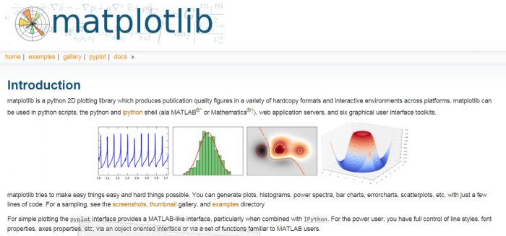

2. Pandas
Pandas provides fast, flexible, and expressive data structures designed to make working with structured (tabular, multidimensional, potentially heterogeneous) and time series data both easy and intuitive.
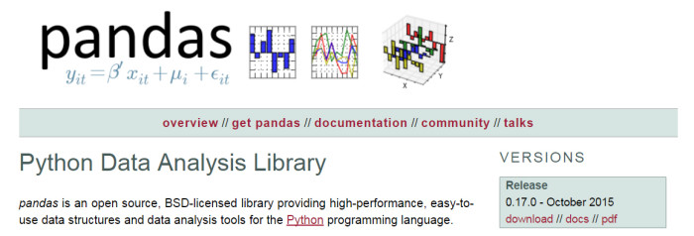

3. Requests
Is a must have for any python developers. It allows you to send HTTP/1.1 requests, add headers, form data, multipart files, and parameters with simple Python dictionaries, and access the response data in the same way.
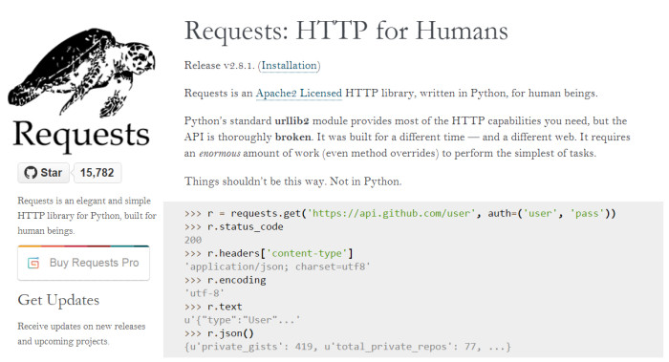
4. SQLAlchemy
Provides a full suite of well-known enterprise-level persistence patterns, designed for efficient and high-performing database access, adapted into a simple and Pythonic domain language.
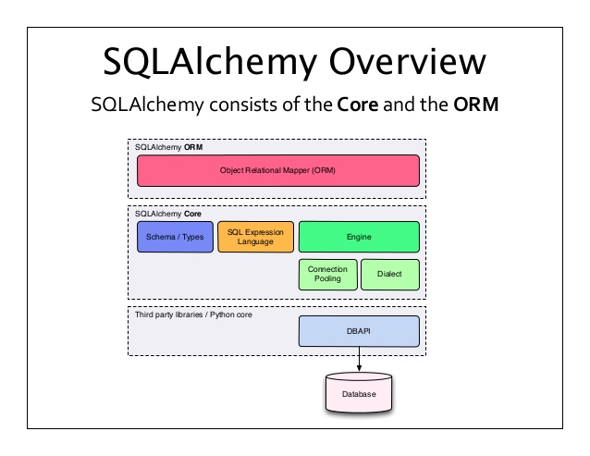
5. NumPy
Provides advance math functionalities and a fundamental package for scientific computing with Python.
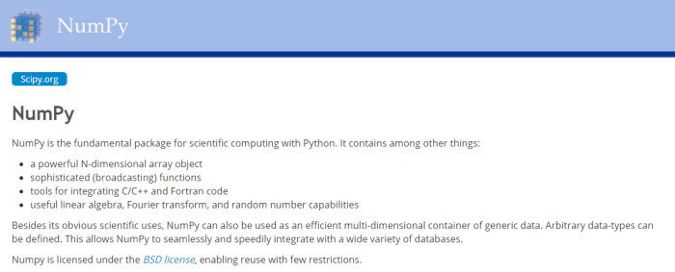

6. Pyglet
Provides an object-oriented programming interface for developing games and other visually-rich applications for Windows, Mac OS X and Linux. This is the engine in which the popular game Minecraft was made.
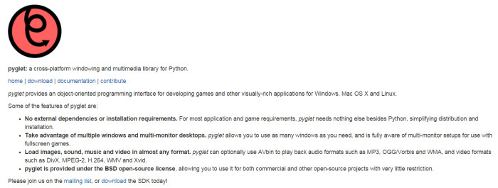

7. BeautifulSoup
It may be slow but it’s xml and html parsing library is very useful for beginners.
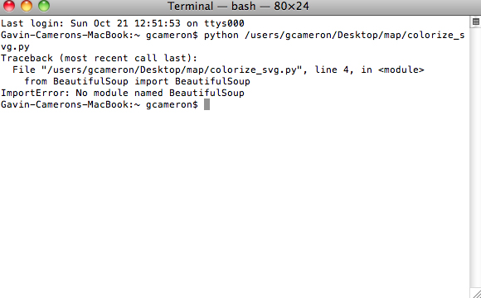

8. SciPy
SciPy is one of the core packages that make up the SciPy stack. It provides many user-friendly and efficient numerical routines such as routines for numerical integration and optimization.
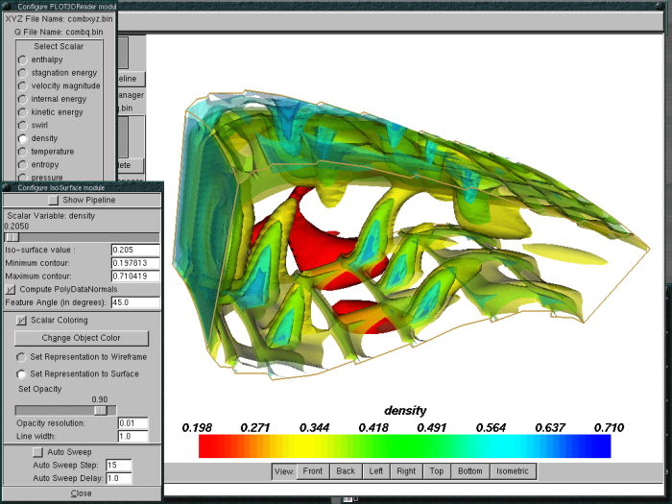

9. Pygame
Pygame provides a very easy to use and powerful Python interface to the Simple Directmedia Library (SDL) platform independent graphic, audio and input libraries.

10. Scrapy
Provides a fast high-level screen scraping and web crawling framework. It can be used for a wide range of purposes, from data mining to monitoring and automated testing.
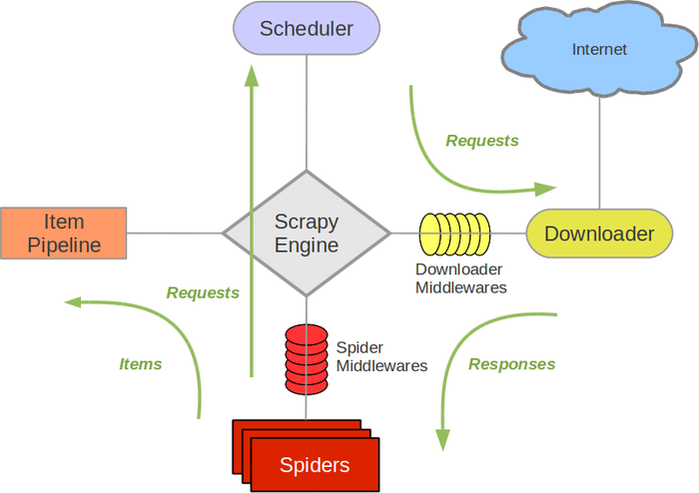

11. Twisted
Twisted is an event-driven networking engine written in Python and licensed under the open source MIT license. Twisted runs on Python 2 and an ever growing subset also works with Python 3.
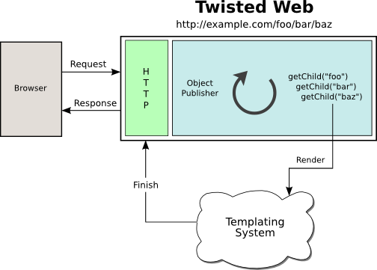

12. Pillow
A friendly fork of PIL (Python Imaging Library). It is more user friendly than PIL and is a must have for anyone who works with images.


13. wxPython
WxPython is a wrapper around wxWidgets for the Python language.
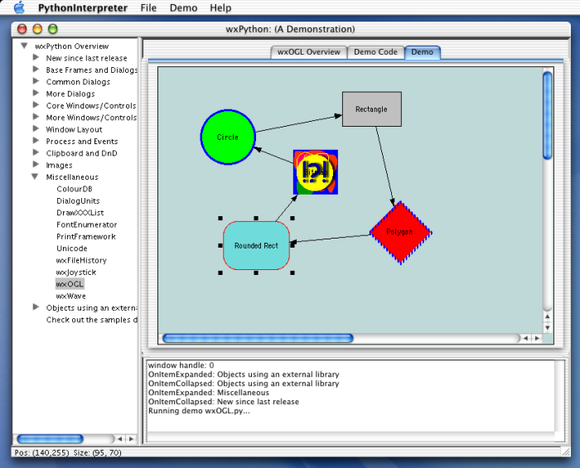

14. pywin32
Pywin32 is a python library which provides some useful methods and classes for interacting with windows.
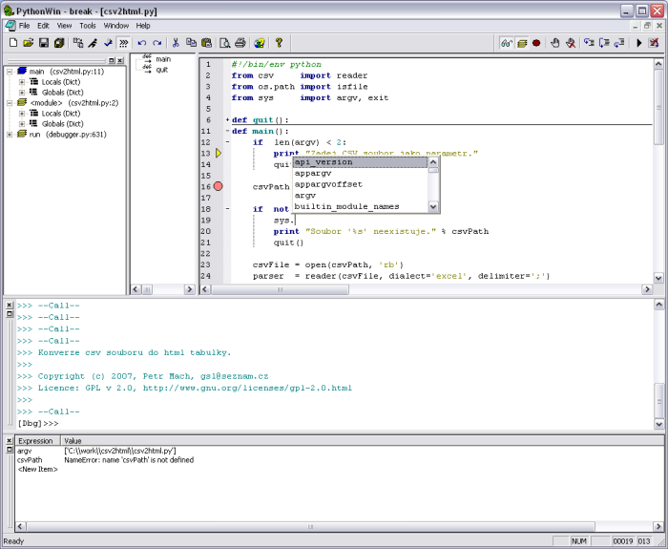

15. iPython
Based on an architecture that provides parallel and distributed computing. IPython enables parallel applications to be developed, executed, debugged and monitored interactively.
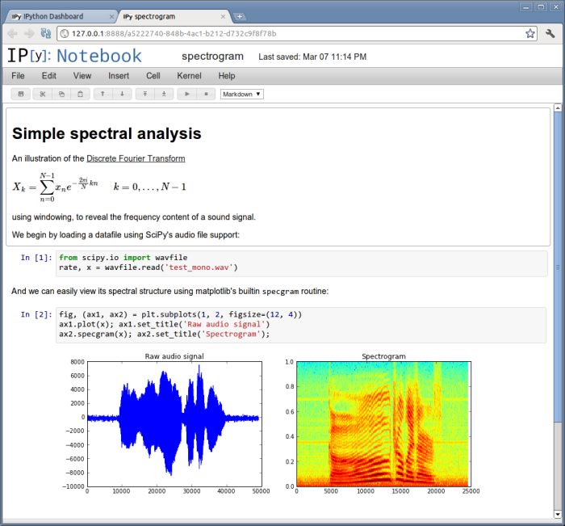

16. Nose
Provides an alternate test discovery and running process for unittest, one that is intended to mimic the behavior of py.test as much as is reasonably possible without resorting to too much magic.
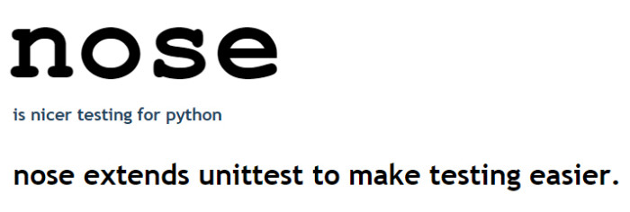

17. PyGTK
Lets you to easily create programs with a graphical user interface using the Python programming language.
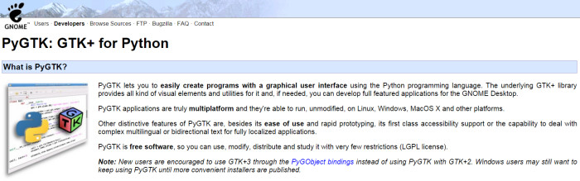

18. Flask
Flask is a Python web framework built with a small core and many extensions.


19. SymPy
SymPy is an open source Python library for symbolic mathematics. It aims to become a full-featured computer algebra system (CAS) while keeping the code as simple as possible in order to be comprehensible and easily extensible. SymPy is written entirely in Python and does not require any external libraries.
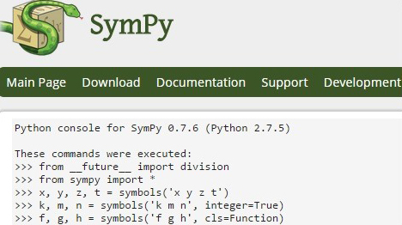

20. Fabric
Fabric is a Python library and command-line tool for streamlining the use of SSH for application deployment or systems administration tasks. It provides a basic suite of operations for executing local or remote shell commands and uploading/downloading files, as well as auxiliary functionality such as prompting the running user for input, or aborting execution.
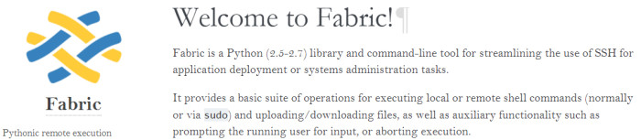
GET YOUR FREE PYTHON EBOOK!
1. doit
doit comes from the idea of bringing the power of build-tools to execute any kind of task

python logo
pip install doit
People often compare doit to tools like make, grunt, rake, scons, snakemake.

They appreciate doit strong features, flexibility, simplicity of authoring and ease of use.

2. Textual and Rich
https://github.com/Textualize/rich
https://github.com/Textualize/textual
pip install rich
python -m rich

